## 

User Manual

April 2017

Version 0.08

Team Intereus is a team of Undergraduate students from Indiana University Southeast.

Copyright© 2017 Team Intereus

Document Revisions

|  |  |  |
| --- | --- | --- |
| Date | Version Number | Document Changes |
| 04/13/2017 | 0.01 | Initial Draft - Created initial Layout of User's Manual |
| 04/18/2017 | 0.02 | Added document formatting and projected contents |
| 04/24/2017 | 0.03 | Set up basic structure, added more template notes, Completed Section 3.1 |
| 04/26/2017 | 0.04 | First draft of Section 1.5, added icons, some proofreading |
| 04/29/2017 | 0.05 | First draft of Section 6 |
| 04/30/2017 | 0.06 | First draft of Section 2 |
| 04/30/2017 | 0.07 | First draft of Section 7-11 |
| 04/30/2017 | 0.08 | First draft of Section 4.1, 4.2 and 4.4 |
|  |  |  |

[NOTE: DO NOT manually format text. Follow the Style Sheet at the bottom of this document.]

Table of Contents

[1.1….Title Page 1](#_Toc481334014)

[Introduction 6](#_Toc481334015)

[1.2 Scope and Purpose 6](#_Toc481334016)

[1.3 Distribution and Validation 6](#_Toc481334017)

[1.4 Icons Used in this Manual 7](#_Toc481334018)

[1.5 Process Overview 7](#_Toc481334019)

[2 Presentation of the Solution 9](#_Toc481334020)

[2.1 Brief Description 9](#_Toc481334021)

[2.2 Project Players 9](#_Toc481334022)

[2.3 Support 9](#_Toc481334023)

[2.4 Referenced Documentation 10](#_Toc481334024)

[2.5 History of the Solution 10](#_Toc481334025)

[3 Connecting to the Application 11](#_Toc481334026)

[3.1 Address 11](#_Toc481334027)

[3.2 Authentication 11](#_Toc481334028)

[4 Structuring of the Mobile Application 12](#_Toc481334029)

[4.1 Mobile Layout 12](#_Toc481334030)

[4.2 Menus 13](#_Toc481334031)

[4.3 Icons / Shortcuts 13](#_Toc481334032)

[4.4 Functionalities 13](#_Toc481334033)

[4.4.1 Functionalities Presented/Described 13](#_Toc481334034)

[4.4.2 Functionalities not Presented/not Described 13](#_Toc481334035)

[5 Map / Search 15](#_Toc481334036)

[5.1 Operation of the Map 15](#_Toc481334037)

[5.1.1 Scrolling the map 15](#_Toc481334038)

[5.1.2 Zooming the map 15](#_Toc481334039)

[5.1.3 Viewing a truck’s information 15](#_Toc481334040)

[6 Login 16](#_Toc481334041)

[6.1.1 Logging in to the Website 16](#_Toc481334042)

[6.1.2 Logging into the Mobile Application 17](#_Toc481334043)

[6.1.3 Resetting your password 18](#_Toc481334044)

[7 Broadcast 20](#_Toc481334045)

[7.1.1 Starting a broadcast 20](#_Toc481334046)

[7.1.2 Ending an active broadcast 20](#_Toc481334047)

[8 Truck List 21](#_Toc481334048)

[8.1.1 Viewing a truck 21](#_Toc481334049)

[9 Event List 21](#_Toc481334050)

[10 Social Media 21](#_Toc481334051)

[11 About 22](#_Toc481334052)

[12 Etc 22](#_Toc481334053)

[13 Appendices 22](#_Toc481334054)

[14 Index 23](#_Toc481334055)

[14.1 Style Sheet Information 24](#_Toc481334056)

[15 Heading 1 24](#_Toc481334057)

[15.1 Heading 2 24](#_Toc481334058)

[15.1.1 Heading 3 24](#_Toc481334059)

[Replace TOC once the document structure is finalized]

# Introduction

## Scope and Purpose

[Introduce the product and its purpose, highlighting key features and benefits]

Truck Pup is a mobile and website-based application for tracking a fleet of food trucks. The individual trucks can set up menus, including pricing information, manage the social network links, schedule events, and customize their profile.

[Introduce the purpose of the user guide, what functionality or workflows will be covered? Are there any assumptions about the users’ knowledge or experience, or prerequisites? ]

This user manual gives an overview of the operation of key features of the Truck Pup mobile app and website. The mobile app will be covered in Section X, and will include installation instructions and detailed instructions for common tasks with each feature. The website will be covered two Sections. Section X will cover the compatible browsers, and detailed instructions on the use of the features, and Section X+2 which will include information on the Administrator features.

## Distribution and Validation

This user manual will be available to download from the website’s server, and will be available online at the Team Intereus website: <http://ada.ius.edu/~cmcguire/>

This document is valid for 6 months or until a major feature upgrade has been made to Truck Pup causing a change in the whole version number.

## Icons Used in this Manual

|  |  |  |
| --- | --- | --- |
| Example | Name | Description |
| D:\IUS Projects\445\samples\icon.png | Truck Pup Logo | Identifies the application on the user’s device |
| D:\IUS Projects\445\ionic\resources\truck.png | Truck Icon | Denotes the location of a food truck on the map interface |
| D:\IUS Projects\445\ionic\platforms\android\assets\www\img\ionic.png | Ionic Logo | Denotes a requirement or feature of the Ionic platform |
| D:\IUS Projects\445\ionic\platforms\android\assets\www\img\intereusLogo_red3dsh.png | Intereus Logo | Identifies the development team |
| https://maps.gstatic.com/intl/en_us/mapfiles/markers2/measle_blue.png | Google Dot (Blue) | Identifies the current location of the user of the application on the Google Map |
|  | Arrow (Green) | Draws attention to an important note or warning |

## Process Overview

[Provide a concise description of the overall processes managed by the software, and how the user interacts with the system. As applicable, reference related processes and corresponding documentation (you may want to create an ordered list of each workflow/process to be covered).]

[typical sequence for using the software to manage {group of workflows/functions}:

1. Configure your workspace
2. Manage a key workflow
3. Manage another key workflow
4. Report
5. Troubleshoot]

[You may choose to include a process flow diagram to accompany the text. Consider including subprocess diagrams throughout the guide to introduce new or subsequent workflows]

There are three roles which are active in the use of this program: users, truck owners, and administrators. Users are able to view truck information from the mobile application. Truck owners will be given invitations by the administrator(s) to create an account using the website, and they will broadcast their location using the mobile application during their regular hours of operation. Administrators will be responsible for creating and managing the user accounts, and will use the website to perform the necessary tasks.

Users will primarily use the mobile application to track the location of all active trucks, view profiles of registered trucks, and view upcoming events. They will not have to log on to perform these actions.

For Truck Operators, the web application is used for account creation, profile and menu management, and scheduling events. Truck operators will use the web application to perform all basic functions, as well as broadcasting their current location.

Administrators will primarily use the website to manage user accounts, including creation/deletion, activation, password recovery, and account disabling.

# Presentation of the Solution

## Brief Description

[Provide a concise description of the context for this process or workflow, including any requirements or conditions that are relevant. Repeat this entire section for each major workflow or process.]

Truck Pup is a cross-platform mobile and web application designed for food truck vendors in the Louisville Food Truck Association. Food truck vendors operate at different location with flexible hours, make it inconvenient for a customer to reliably eat at their favorite truck. Truck Pup connects customers and vendors by broadcasting a truck’s current geocoded position through our mobile app. The mobile app also provides other truck-specific information such as operation status, menu information, and upcoming events. Data is handled efficiently and securely using a customized website hosted on a cloud server.

## Project Players

[List all the players impacted by the project/solution here:

* Owner of the application
* Owner of the data ]

The owner of the application and its associated data is the Louisville Food Truck Association, represented by the current chair Leah.

LFTA website: <http://www.louisvillefoodtruckassociation.com/>

LFTA twitter: <https://twitter.com/LouFoodTrucks>

## Support

[List what is needed for a support request here:

• Telephone

• E-mail

• Dedicated application

• …

Describe how to track the progress of the request in order to avoid excessive telephoning]

Requests for support should be directed to the Louisville Food Truck Association via the E-mail listed below.

E-mail: [LouisvilleFoodTruckAssociation@gmail.com](mailto:LouisvilleFoodTruckAssociation@gmail.com)

## Referenced Documentation

[Some documentation may be useful to the user in helping them understand how application-related modules work.

List them here if applicable.]

Software design documents and brief description of the application can be found on the Team Intereus Website <http://ada.ius.edu/~cmcguire/>

## History of the Solution

*[Give the background here to the various stages in developing the solution from a user viewpoint.]*

This documentation is for the initial release of the Truck Pup application.

If you encounter issues not addressed by this user guide, please contact your account manager for additional support.

# Connecting to the Application

## Address

You must connect to the application using the following address:

<http://web.ephemerant.com>

<http://mobile.ephemerant.com>

## Authentication

[Indicate here what information must be given by the user to log on: login AD, surname first name, e-mail address etc.

Insert a screenshot of the authentication page.

Explain and show a screenshot of the page refusing unauthorized access. ]

# Mobile Application Structure

## Mobile Layout

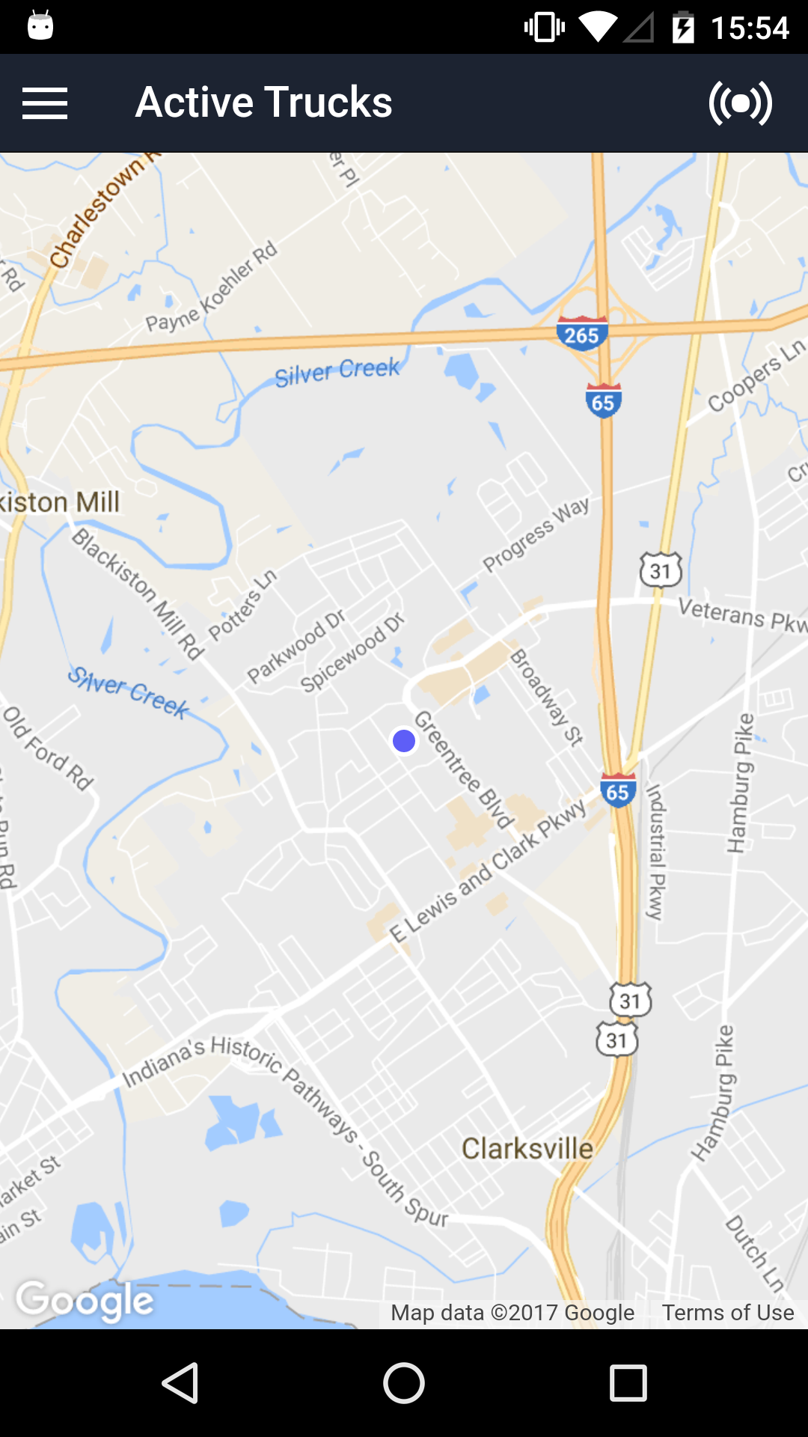

Current Location

Broadcast Radial Button

Menu Bar

Map area

[For a web application describe the structuring of the pages if they follow the same pattern.

An example is given below.]

## Menus

[List the menus, shown in tree-structure]

## Icons / Shortcuts

[Show each icon or shortcut, together with a description.]

## Functionalities

### Functionalities Presented/Described

[List here all the functionalities that will be described in the document.

You could group together a number of similar functions or functionalities linked within a workflow for example. These groupings should be shown here to give the user the map they need to read the document. ]

Map/Search

Truck List

Login

### Functionalities not Presented/not Described

[List here all the functionalities that will not be described in the document.

It is not necessary to present all the functionalities of an application:

because it is already described elsewhere: you could insert a link or reference etc

because the functionality is unimportant…]

About

Social Media

Event List

# Map / Search

This section describes the map and search functions of the mobile application.

## Operation of the Map

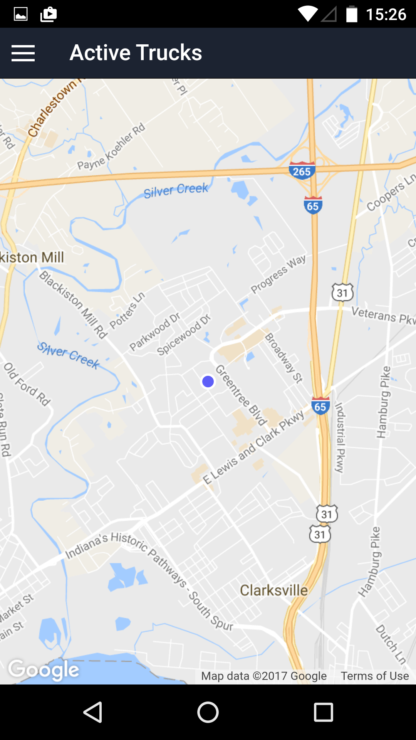

### Scrolling the map

1. Touch the screen then drag. The map will scroll in the opposite direction of your movement

### Zooming the map

1. Touch the screen with two fingers. Adjust the space between your fingers to change the zoom level of the map.
2. Pull them closer to zoom out
3. Push them farther apart to zoom in

### Viewing a truck’s information

1. Touch the screen over a truck icon. This will give you detailed information about that truck.
2. If there are several trucks in the same area the icons will separate. Touch an icon to view individual truck information.

# Login

This section describes the procedures to log on to the website and mobile application.

### Logging in to the Website

1. In your browser, Go to the website URL https://web.ephemerant.com/login

NOTE: If you have forgotten your user name or password, follow the reset password procedure.

1. Type in user email
2. Type in user password

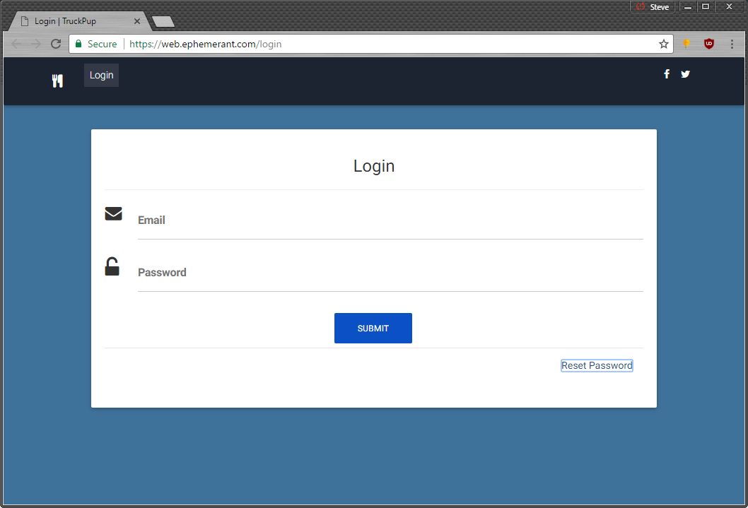

1. Click Login button with your mouse
2. If the login is successful you will be brought to the account homepage.

### Logging into the Mobile Application

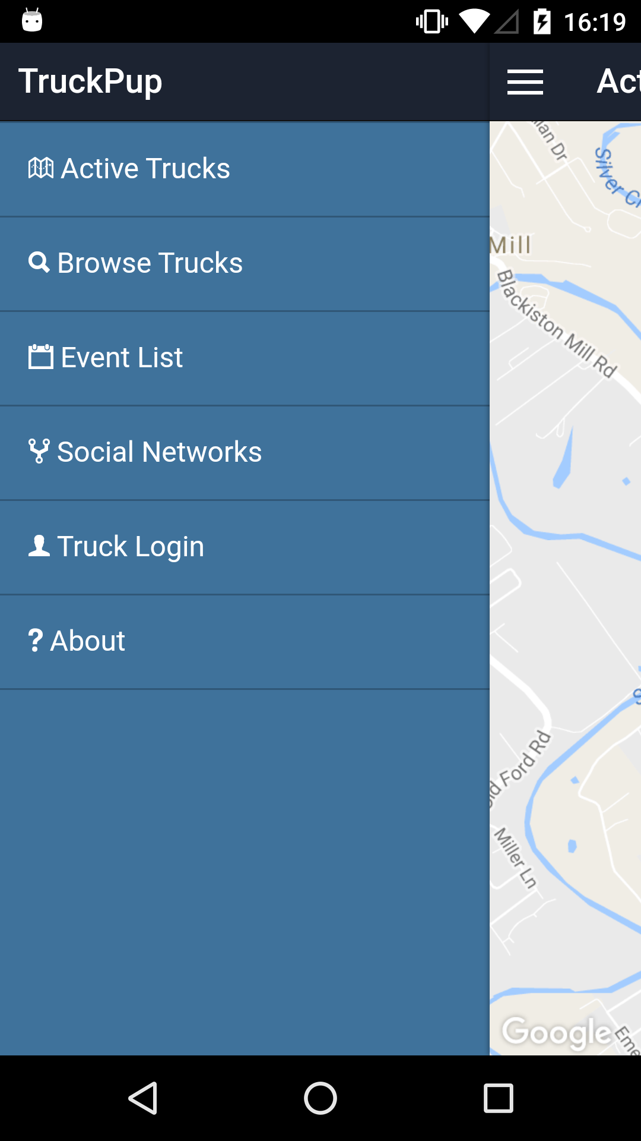

1. Open the Truck Pup Application on your mobile device and touch the menu icon
2. Touch Truck Login

NOTE: If you have forgotten your user name or password, follow the reset password procedure.

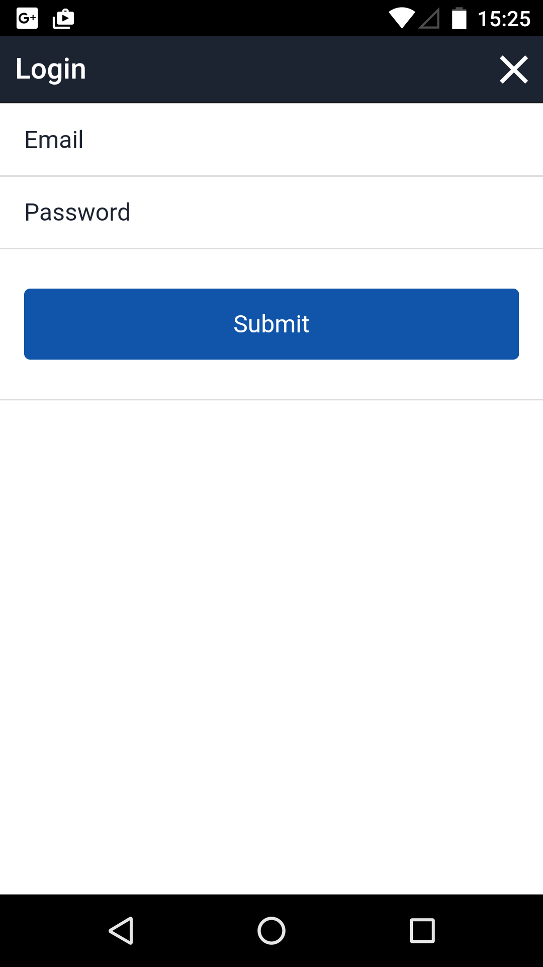

1. Type in user email
2. Type in user password
3. Click Submit button
4. If the login is successful you will return to the map view

### Resetting your password

NOTE: You will need a registered email in order to complete this step

1. In your browser, Go to the website URL <https://web.ephemerant.com/login>
   1. This will cause a pop-up window to appear which will be used to complete the following steps.
2. Click reset password
3. Click Submit
   1. This will send a reset email to address entered.

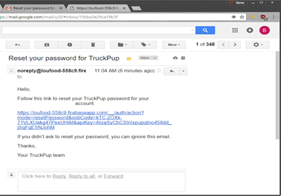

1. Find the reset password email from noreply@loufood-558c9.firebaseapp.com
2. Click the reset password link in the email
   1. This will open the secure link in your browser to the password reset page

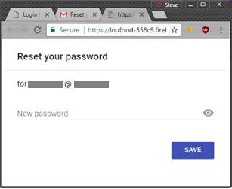

1. Type in the new password in the field provided
2. Click the save button
3. Return to the previous Login step and use your updated password

# Broadcast

This function on the mobile application is used by truck owners to broadcast or end a broadcast of their current location.

NOTE: This function is for truck owners that are currently logged in to the application. See Section 6 for details.

### Starting a broadcast

1. Touch the broadcast radial button in the upper right. This will open the broadcast modal window.
2. Choose the number of hours the phone will broadcast its location. The default value is 4 hours.
3. Touch the Submit Button

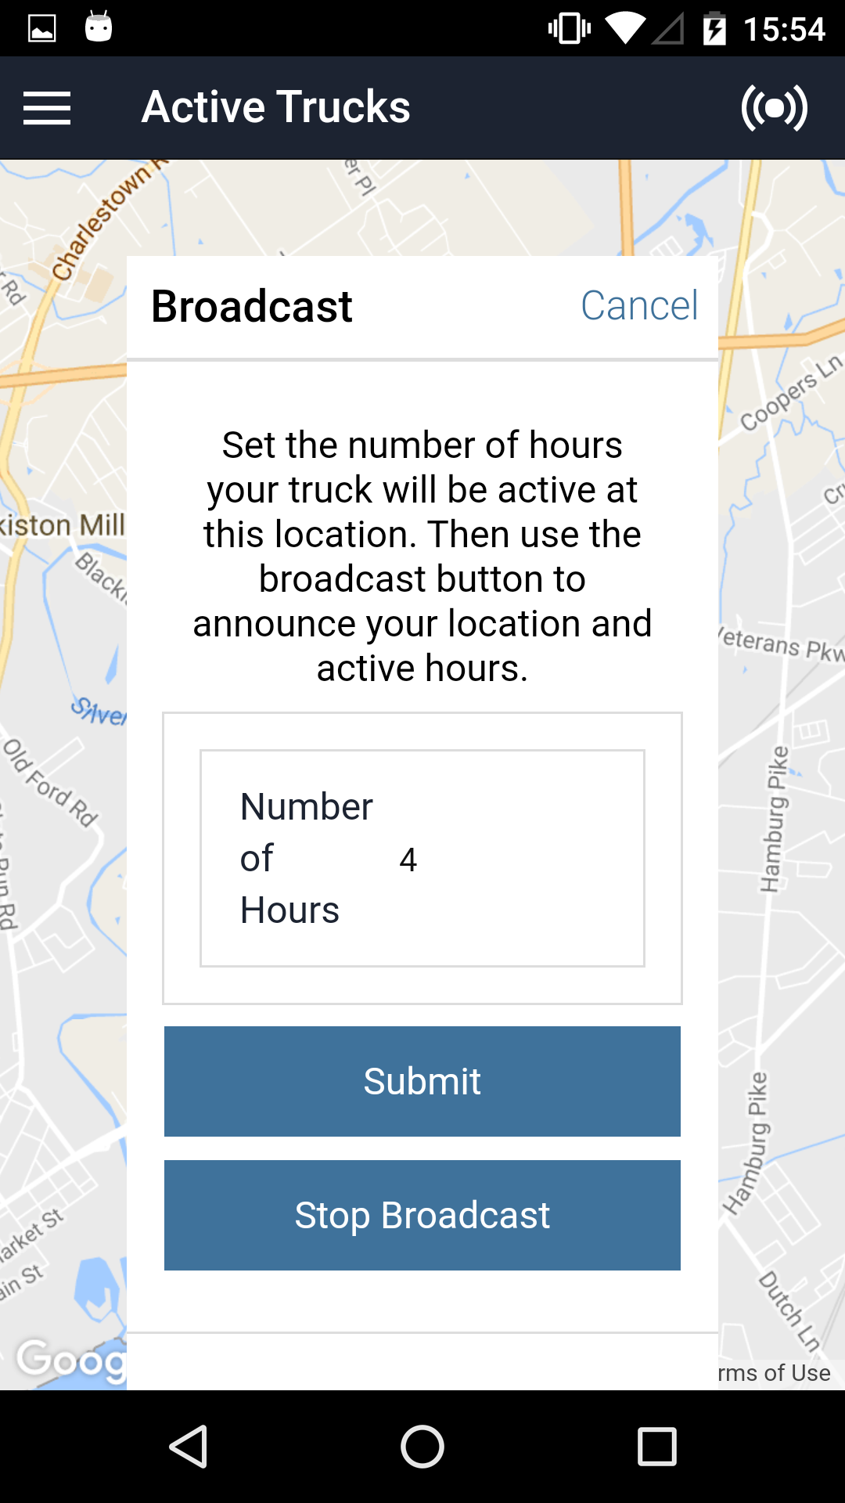

### Ending an active broadcast

1. Touch the broadcast radial button in the upper right. This will open the broadcast modal window.
2. Touch the Stop Broadcast button

# Truck List

This function on the mobile application shows a list of all the trucks registered and active in the database.

### Viewing a truck

1. Touch the main menu icon
2. Touch the Browse Trucks button
3. Select a truck to view. This will take you to the truck’s information page.

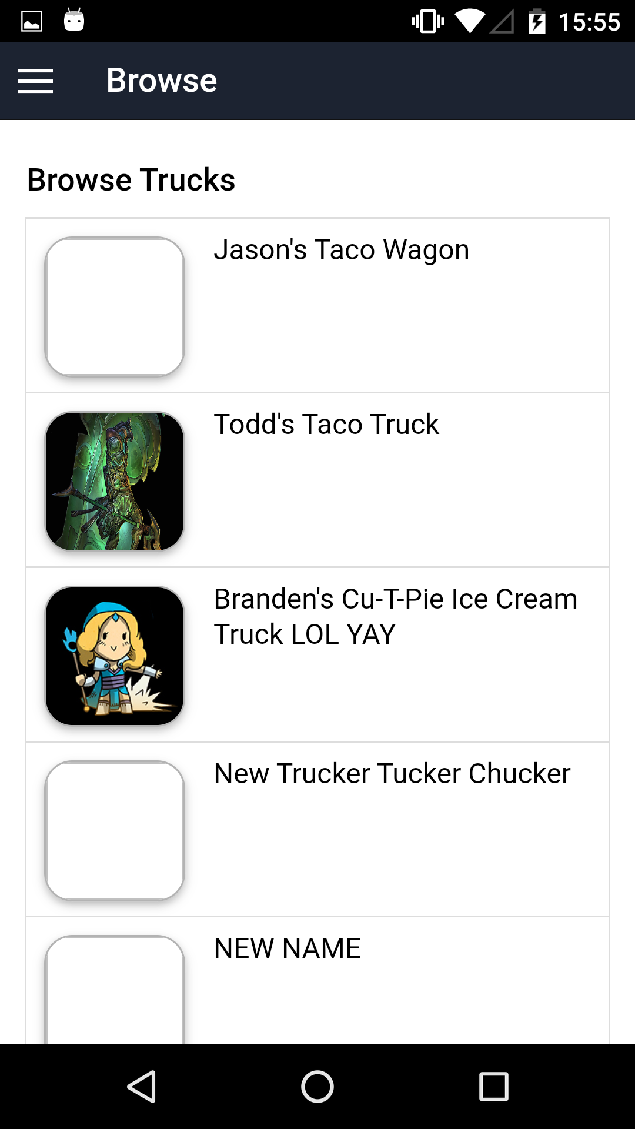

# Event List

This feature is not completed on the original release of the mobile application.

# Social Media

This feature is not completed on the original release of the mobile application.

# About

This software was released as a part of undergraduate coursework at Indiana University Southeast. For more details please visit the Team Intereus website <http://ada.ius.edu/~cmcguire/>

# Etc

[Need to make the website and app into different chapters with subsections]

# Appendices

[Appendices are optional, and are used to provide additional detailed information that may help the end user manage the overall application. Examples could include references to standards (such as W3C standards), technical specifications required for regulatory compliance, checklists, or other information of a technical nature.

Give here any additional information that could make the functional specifications easier to understand.]

# Index

[Depending on the size or complexity of the final document, consider pulling together an index to assist the using in location specific information. Index entries correspond to tags or categories, and are useful in navigating long books.]

## Style Sheet Information

The following styles have been set up in this template. Avoid applying manual character formatting to the document. Applying these styles will assist in the conversion process if the document is to be laid out in a structured authoring tool, content management tool, or an HTML editor.

| Style Name | Apply to |
| --- | --- |
| Title | Title as listed on the cover page of the document |
| Subtitle | Subtitle as listed on the cover page of the document |
| Heading 1 | Chapter Name or Process or Workflow |
| Heading 2 | Subsection or SubProcess or Workflow step |
| Heading 3 | Subsection 2 or Procedure |
| Callout Block Copy Note | Notes, cautions or warnings, use arrow graphic on the left margin |
| Chapter Body Copy | Generic text following a heading |
| * Chapter Body Copy – Bullet | Unordered list within a section or subsection, sometimes within a Step to indicate alternative ways to do something. |
| * + Chapter Body Copy – Bullet 2 | A secondary unordered list, within a higher level ordered or unordered list |
| 1. Chapter Body Copy – Step | An ordered list (sequential) used in a procedure to indicate the order of actions to be taken |
| 1. Chapter Body Copy – Step a | A secondary ordered list, e.g. substeps in a procedure |
| Chapter Body Copy – Indent | Sets additional text inward so that it aligns with either Chapter Body Copy – Bullet or Chapter Body Copy – Step |
| Chart Body Copy | Text within a table |
| Chart Header Information | The first row of a table. |
| Caption | Descriptive text for a table or graphic. |
| Header | Text that appears at the top of each page. |
| Footer | Text that appears at the bottom of each page. |
| Chart Title and Footer Info | Copyright and other front matter preceding the Table of Contents; additional information used to footnote or provide a legend for a table. |
| TOC Heading | Heading used for Table of Contents, Table of Figures (if applicable), and the Document Revisions pages of the front matter to the document. |
| TOC 1 | TOC display information for a chapter. Generated automatically from Heading 1. |
| TOC 2 | TOC display information for a sub-section. Generated automatically from Heading 2. |
| TOC 3 | TOC display information for a subsection 2. Generated automatically from Heading 3. |
| [Template Instructions] | Guidance on building out the user guide. Should be deleted prior to publishing. |